Name:
Period:
Date:

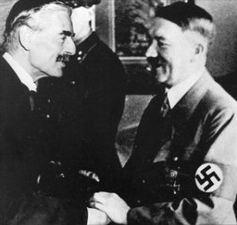
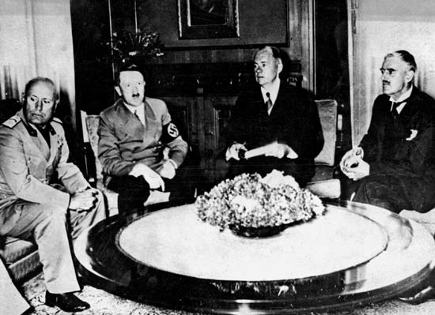
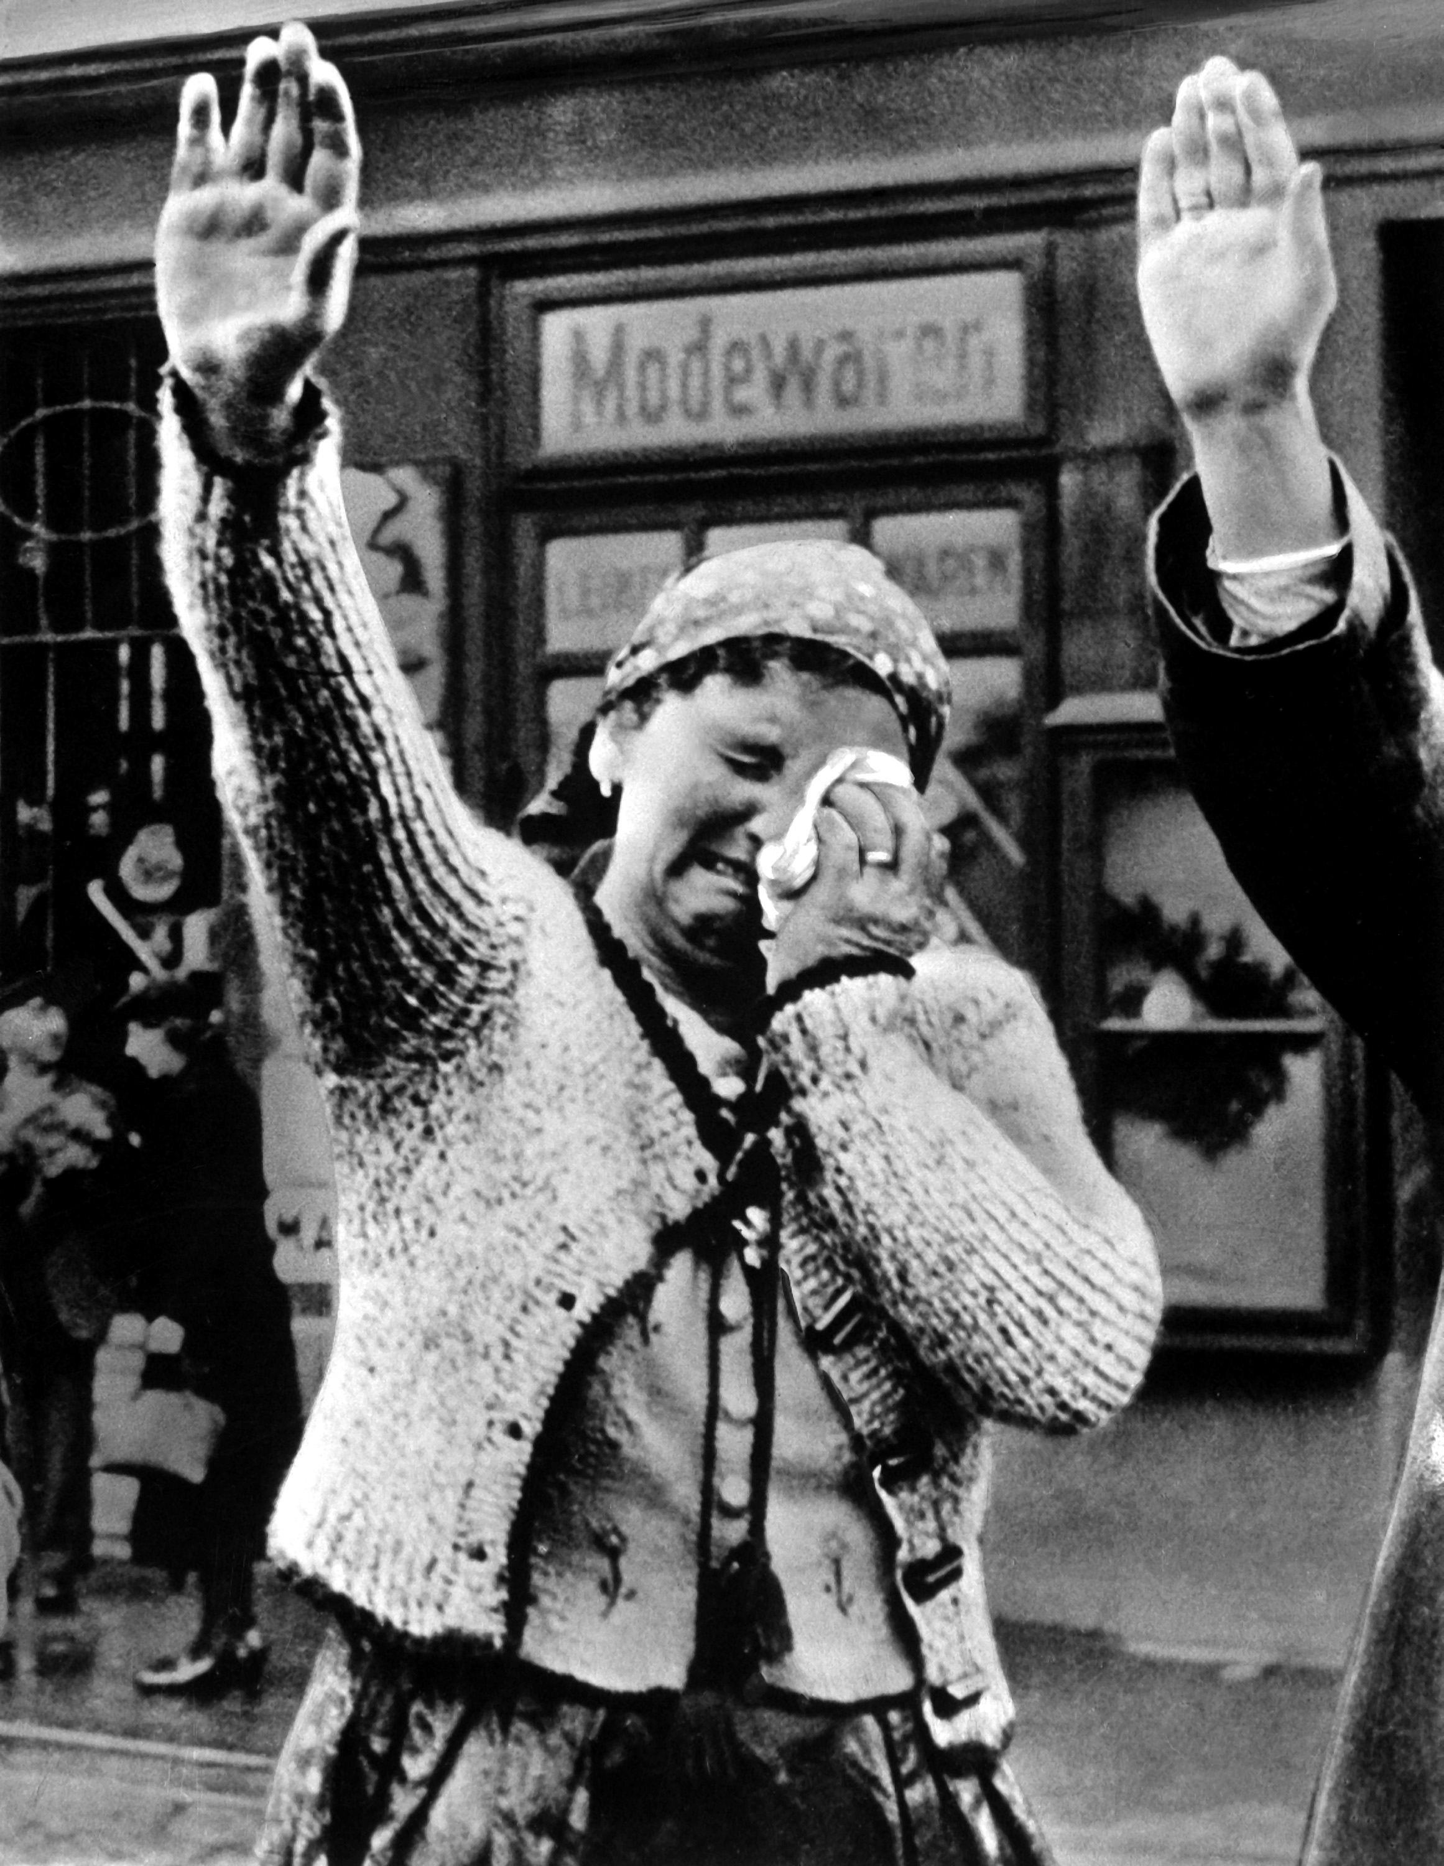
Strategy of Appeasement Guided Notes

Directions: As you view the presentation fill out this handout. The Munich Conference political cartoon activity is on the last page.

Vocabulary

1.Appeasement:_______________________________________________________________________________________________________________________________________________

2. Third Reich: _________________________________________________________________
______________________________________________________________________________

3. Munich Conference: ___________________________________________________________ ______________________________________________________________________________

France and Britain choose to appease

What did Neville Chamberlain Prime Minister of Britain and Prime Minister of France Edouard Daladier firmly believe in? _______________________________________________________

Who did Chamberlain and Daladier want to appease in order to avoid another war? ___________

Why appease Hitler?

How many deaths did World War I cause? ___________________________________________

How much did WWI cost to fight? _________________________________________________

How did most European nations feel about war? ______________________________________
_____________________________________________________________________________

Checking for Understanding
Do you think that Hitler was aware that Chamberlain and Daladier wanted to appease him? ____________________________________________________________________________________________________________________________________________________________

Do you think that it was possible to stop Hitler’s ambition to create a German empire? ________
____________________________________________________________________________________________________________________________________________________________

Rise of Hitler’s Nazi Germany

What did Hitler want to create? ____________________________________________________

What are two ways in which Hitler violated the Treaty of Versailles?
- _____________________________
- _____________________________

What happened after Hitler annexed the Sudetenland? __________________________________
______________________________________________________________________________

The Munich Conference

What was the agreement that at came about in the Munich Conference? ____________________
____________________________________________________________________________________________________________________________________________________________

Was War Avoided?

How did many people feel about the decision to give Hitler the Sudetenland and how was Chamberlain welcomed upon his return to England? ___________________________________
____________________________________________________________________________________________________________________________________________________________

What did Chamberlain mean by the quote, “I believe it is peace for our time.” _______________
____________________________________________________________________________________________________________________________________________________________

Checking for Understanding

What did Churchill mean by, “An appeaser is one who feeds a crocodile, hoping it will eat him last.” _________________________________________________________________________
______________________________________________________________________________

Hitler Breaks his Promise

Did Hitler keep his promise, or did he break it? Explain. ________________________________
______________________________________________________________________________
What was the last straw for Britain and France? What did you promise? ____________________
____________________________________________________________________________________________________________________________________________________________

Checking for Understanding

Do you think that Hitler took Britain and France seriously? _____________________________
______________________________________________________________________________
______________________________________________________________________________

What do you think that Hitler is planning next? _______________________________________
____________________________________________________________________________________________________________________________________________________________

MUNICH CONFERENCE POLITICAL CARTOON

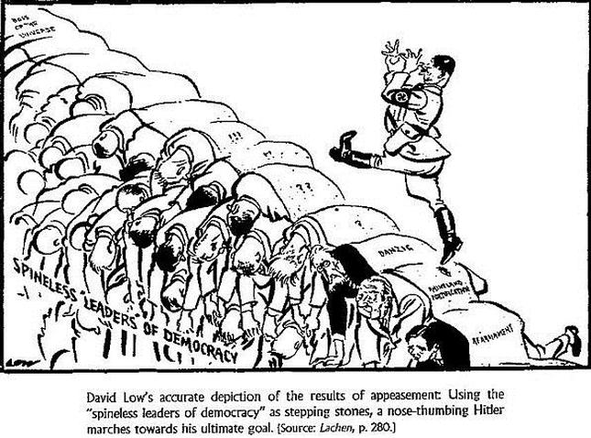

1. What is Hitler stepping on?

2. On what path do you believe Hitler is on?

3. Do you think that Hitler knows where he is going?

4. What do you think is the message of this political cartoon?

