Name:
Period:
Date:
Primary Sources Worksheet

Directions: Please read your assigned primary source and analyze it by answering the guiding questions that pertain to the source that your group is focusing on. Also be sure to provide a brief summary of the source, as you will present your source as a group. While other groups are presenting follow along by filling out the section that pertains to the primary source that they are presenting.

Primary Source #1

Franklin Delano Roosevelt’s “Day of Infamy” Speech

Yesterday, December 7, 1941 - a date which will live in infamy - the United States of America was suddenly and deliberately attacked by naval and air forces of the Empire of Japan.
The United States was at peace with that nation and, at the solicitation of Japan, was still in conversation with its Government and its Emperor looking toward the maintenance of peace in the Pacific. Indeed, one hour after Japanese air squadrons had commenced bombing in Oahu, the Japanese Ambassador to the United States and his colleague delivered to the Secretary of State a formal reply to a recent American message. While this reply stated that it seemed useless to continue the existing diplomatic negotiations, it contained no threat or hint of war or armed attack.
It will be recorded that the distance of Hawaii from Japan makes it obvious that the attack was deliberately planned many days or even weeks ago. During the intervening time the Japanese Government has deliberately sought to deceive the United States by false statements and expressions of hope for continued peace.
The attack yesterday on the Hawaiian Islands has caused severe damage to American naval and military forces. Very many American lives have been lost. In addition American ships have been reported torpedoed on the high seas between San Francisco and Honolulu.
Yesterday the Japanese Government also launched an attack against Malaya. Last night Japanese forces attacked Hong Kong. Last night Japanese forces attacked Guam. Last night Japanese forces attacked the Philippine Islands. Last night the Japanese attacked Wake Island. This morning the Japanese attacked Midway Island.
Japan has, therefore, undertaken a surprise offensive extending throughout the Pacific area. The facts of yesterday speak for themselves. The people of the United States have already formed their opinions and well understand the implications to the very life and safety of our nation.
As Commander-in-Chief of the Army and Navy, I have directed that all measures be taken for our defense.
Always will we remember the character of the onslaught against us. No matter how long it may take us to overcome this premeditated invasion, the American people in their righteous might will win through to absolute victory.
I believe I interpret the will of the Congress and of the people when I assert that we will not only defend ourselves to the uttermost but will make very certain that this form of treachery shall never endanger us again.
Hostilities exist. There is no blinking at the fact that our people, our territory and our interests are in grave danger.
With confidence in our armed forces - with the unbounded determination of our people - we will gain the inevitable triumph - so help us God.
I ask that the Congress declare that since the unprovoked and dastardly attack by Japan on Sunday, December seventh, 1941, a state of war has existed between the United States and the Japanese Empire.
1. To who is the speech addressed? _________________________________________________
____________________________________________________________________________________________________________________________________________________________
2. What evidence does Franklin D. Roosevelt use to demonstrate that the Japanese attack on Pearl Harbor was a surprise and that it was premeditated? Are you convinced by Roosevelt’s arguments? ____________________________________________________________________
________________________________________________________________________________________________________________________________________________________________________________________________________________________________________________________________________________________________________________________
3. What feelings is President Roosevelt trying to invoke? What does Franklin Delano Roosevelt say is at stake? _________________________________________________________________
________________________________________________________________________________________________________________________________________________________________________________________________________________________________________________________________________________________________________________________
Primary Source #2

Tattered U.S. Flag
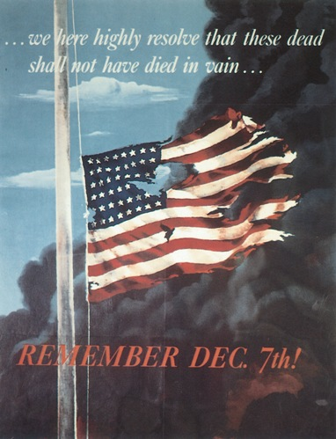
1. What is the text on the poster trying to say? ________________________________________
____________________________________________________________________________________________________________________________________________________________
2. What type of poster is this and what is its purpose? __________________________________
__________________________________________________________________________________________________________________________________________________________________________________________________________________________________________
3. Describe the scene depicted in the poster. __________________________________________
__________________________________________________________________________________________________________________________________________________________________________________________________________________________________________
4. What emotions is this poster trying to invoke? Do you think that the poster does a good job of bringing about these emotions? ____________________________________________________
________________________________________________________________________________________________________________________________________________________________________________________________________________________________________________________________________________________________________________________

Primary Source #3
The Axis Dove Lays Its Rotten Egg
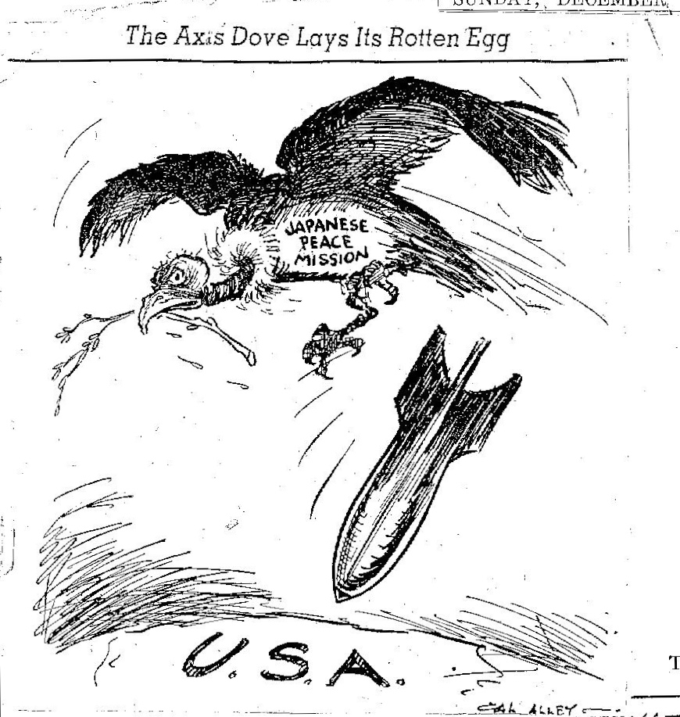

1. What is the political cartoon depicting? What is the significance of the vulture? ______________________________________________________________________________________________________________________________________________________________________________________________________________________________________________________________________________________________________________________________________________________________________________________________________
2. What is the purpose of this political cartoon? Do you think that it does a good job of presenting its message? Why or why not? ____________________________________________
____________________________________________________________________________________________________________________________________________________________
____________________________________________________________________________________________________________________________________________________________
3. What is this political cartoon saying about the Japanese? ______________________________
____________________________________________________________________________________________________________________________________________________________

Primary Source #4
Fourteen Part Message (Japanese note to the United States December 7, 1941; excerpt)

- The government of Japan, prompted by a genuine desire to come to an amicable understanding with the Government of the United States in order that the two countries by their joint efforts may secure the peace of the Pacific Area and thereby contribute toward the realization of world peace, has continued negotiations with the utmost sincerity since April last with the Government of the United States regarding the adjustment and advancement of Japanese-American relations and the stabilization of the Pacific Area.
- It is the immutable policy of the Japanese Government to insure the stability of East Asia and to promote world peace and thereby to enable all nations to find each its proper place in the world.
- Ever since China Affair broke out owing to the failure on the part of China to comprehend Japan's true intentions, the Japanese Government has striven for the restoration of peace and it has consistently exerted its best efforts to prevent the extension of war-like disturbances. It was also to that end that in September last year Japan concluded the Tripartite Pace with Germany and Italy. However, both the United States and Great Britain have resorted to every possible measure to assist the Chungking regime so as to obstruct the establishment of a general peace between Japan and China, interfering with Japan's constructive endeavours toward the stabilization of East Asia. Exerting pressure on the Netherlands East Indies, or menacing French Indo-China, they have attempted to frustrate Japan's aspiration to the ideal of common prosperity in cooperation with these regimes. Furthermore, when Japan in accordance with its protocol with France took measures of joint defense of French Indo-China, both American and British Governments, willfully misinterpreting it as a threat to their own possessions, and inducing the Netherlands Government to follow suit, they enforced the assets freezing order, thus severing economic relations with Japan. While manifesting thus an obviously hostile attitude, these countries have strengthened their military preparations perfecting an encirclement of Japan, and have brought about a situation which endangers the very existence of the Empire. Nevertheless, to facilitate a speedy settlement, the Premier of Japan proposed, in August last, to meet the President of the United States for a discussion of important problems between the two countries covering the entire Pacific area. However, the American Government, while accepting in principle the Japanese proposal, insisted that the meeting should take place after an agreement of view had been reached on fundamental and essential questions.
  - It is impossible not to reach the conclusion that the American Government desires to maintain and strengthen, in coalition with Great Britain and other Powers, its dominant position in has hitherto occupied not only in China but in other areas of East Asia. It is a fact of history that the countries of East Asia have for the past two hundred years or more have been compelled to observe the status quo under the Anglo- American policy of imperialistic exploitation and to sacrifice themselves to the prosperity of the two nations. The Japanese Government cannot tolerate the perpetuation of such a situation since it directly runs counter to Japan's fundamental policy to enable all nations to enjoy each its proper place in the world.
  - Obviously it is the intention of the American Government to conspire with Great Britain and other countries to obstruct Japan's effort toward the establishment of peace through the creation of a new order in East Asia, and especially to preserve Anglo-American rights and interest by keeping Japan and China at war. This intention has been revealed clearly during the course of the present negotiation.
  - Thus, the earnest hope of the Japanese Government to adjust Japanese-American relations and to preserve and promote the peace of the Pacific through cooperation with the American Government has finally been lost. The Japanese Government regrets to have to notify hereby the American Government that in view of the attitude of the American Government it cannot but consider that it is impossible to reach an agreement through further negotiations.

1. How does Japan feel about the collaboration taking place between the United States and themselves? ___________________________________________________________________
____________________________________________________________________________________________________________________________________________________________
2.How does Japan view its place in East Asia? ________________________________________
____________________________________________________________________________________________________________________________________________________________
3. How does Japan view the United States and the West? ________________________________
__________________________________________________________________________________________________________________________________________________________________________________________________________________________________________
3. Does Japan believe that an agreement can be reached with the United States? Does the document make a convincing argument? Why or why not? ______________________________________________________________________________________________________________________________________________________________________________________________________________________________________________________________________________________________________________________________________________________________________________________________________

